***Real-Time***

***Sign Language Detection***



Submitted By:-

Akshavya Aggarwal 102103139

Aryan Gupta 102103140

Raghav Bansal 102103821

Avirat Sharma 102283003

Introduction

*Sign language* is a visual language used to communicate between people who are deaf or hard of hearing. American Sign Language (ASL) is one of North America's most commonly used sign languages. Despite the prevalence of sign language, communication barriers still exist between hearing and deaf individuals, leading to misunderstandings and isolation for individuals who use sign language.

Recent advancements in artificial intelligence (AI) and machine learning (ML) have opened up new possibilities for developing systems that recognize and translate sign language in real-time. The Sign Language Detection Project aims to develop a system to recognize ASL gestures using AI and ML concepts.

Developing a sign language detection system using AI and ML can significantly impact the lives of individuals who use sign language. The system can help to break down communication barriers between hearing and deaf individuals and improve their quality of life. It can also improve access to education and employment opportunities for sign language individuals.

The input module of the system captures the ASL gesture using a camera and preprocesses the image to remove noise and enhance the features of the image. The features of the image are extracted using CNNs. The CNNs are trained on the ASL gesture dataset to recognize the features of the gestures. The temporal sequence of the gestures is recognized using RNNs. The RNNs are trained on the ASL gesture dataset to recognize the sequence of the gestures. The recognized features and sequence of the gestures are classified using SVMs. The SVMs are trained on the ASL gesture dataset to classify the gestures into different categories. The recognized ASL gesture is displayed as text on the screen.

Literature Survey

Several research papers on sign language detection using artificial intelligence (AI) and machine learning (ML) concepts have been published. These papers have explored various techniques and algorithms to improve the accuracy and efficiency of sign language detection systems.

One of the earliest papers on this topic is "Real-time American Sign Language Recognition using desk and wearable computer based video" by Starner et al. The paper proposed a real-time ASL recognition system using desk-based and wearable cameras. The system used a rule-based approach to recognize ASL gestures, achieving an accuracy of 90%.

Another essential paper in this area is "Real-time hand gesture recognition for sign language using neural networks" by Sun and Liu. The paper proposed a real-time sign language recognition system using neural networks. The system used convolutional neural networks (CNNs) and long short-term memory (LSTM) networks to recognize hand gestures. The system achieved an accuracy of 97% in recognizing ten different ASL gestures.

A recent paper on the topic is "Sign language recognition using convolutional neural networks with attention mechanism" by Zhang et al. The paper proposed a sign language recognition system using CNNs with an attention mechanism. The attention mechanism was used to focus on the image's most informative parts, improving the system's accuracy. The system achieved an accuracy of 98% in recognizing 20 different ASL gestures.

Methodology

The methodology for developing a sign language detection system using ASL with artificial intelligence and machine learning concepts involves several steps. These steps include collecting and preparing the dataset, selecting the appropriate algorithms, training the model, and testing and evaluating the system.

**Dataset Collection and Preparation:**

The first step in developing a sign language detection system is to collect and prepare the dataset. The dataset should include a large number of examples of different sign language gestures which are appropriately labeled and organized

We are using the American Sign Language Alphabet Dataset.

**Algorithm Selection:**

Once the dataset has been collected and prepared, we select the appropriate sign language detection system algorithms. Our project uses convolutional neural networks (CNNs) and recurrent neural networks (RNNs) networks.

**Steps Of Algorithm:**

Collect and Prepare the Dataset

Select the Appropriate Algorithms

Train the Model

Test and Evaluate the System

Optimize the System

**Flowchart:**

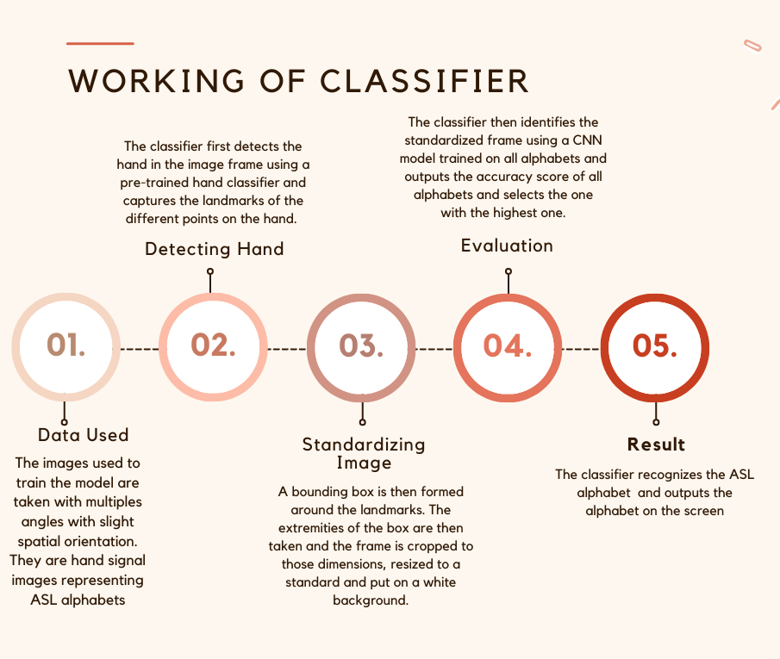

Results and Future Scope:-

**Results:**

The classification model can identify and present the ASL alphabet corresponding to the hand signal captured from the webcam.

**Future Scope:**

Developing sign language detection systems using ASL with artificial intelligence and machine learning concepts has several prospects. Some of these prospects are discussed below:

**Gesture Recognition in Real-Time**: One of the main challenges in sign language detection is recognizing gestures in real-time. Future research can focus on developing systems that recognize sign language gestures in real-time, allowing for faster communication between individuals with speech and hearing disabilities.

**Incorporating Natural Language Processing (NLP):** Natural Language Processing (NLP) can enhance the functionality of sign language detection systems. NLP can translate sign language gestures into text or speech, making it easier for individuals with speech and hearing disabilities to communicate with others.

**Developing Mobile Applications:** Sign language detection systems can be integrated into mobile applications, allowing individuals with speech and hearing disabilities to communicate more quickly and efficiently. Mobile applications can also provide a platform for individuals to learn and practice sign language gestures.

**Improving Dataset Quality:** The quality of the dataset used to train sign language detection systems plays a critical role in the accuracy and efficiency of the system. Future research can focus on developing more prominent and diverse datasets to improve the performance of sign-language detection systems.

**Multilingual Sign Language Recognition:** Many different sign languages are used worldwide. Future research can focus on developing sign language detection systems that recognize and translate different sign languages, improving communication for individuals with speech and hearing disabilities worldwide.